Phlebotomist App Mechanism for Home Collection
Nov 1, 2026 · @purojit

Summary
Build an Android-first phlebotomist app on the existing api/auth sign-in and Lab tables, with one new visit record tracking each home collection from assignment to lab receipt.
- Login: existing credentials, plus phlebotomist check, approved device and own-visits-only access.
- Attendance: GPS and selfie punch against a branch radius; no visit work before Punch In.
- Distance: the server calculates legs between proven stops; payable km is road km, capped by GPS km.
- Status: Assigned, Accepted, On the Way, Reached, In Progress, Sample Collected, Handed Over, Received at Lab.
- Bill change: the phlebotomist requests, the server prices and an approver decides. The bill keeps its number and gains a revision.
- Foundation: every rule is a per-company setting.
Two current code issues must be fixed first: other Lab API controllers still fall back to user 1, and home samples reach lab worklists before they reach the lab. The design is checked against itDose's published phlebotomist apps; a live demo must confirm what their store pages do not show, namely bill change, distance and cash handling.

What exists today
The masters and the lab side are ready, but nothing covers the field visit. A phlebotomist is a user flag and a name on the bill. No code records attendance, location or any step between booking and collection.
Area | In EMR_Dev today | Gap for the app
Phlebotomist profile | Users.IsPhlebotomist, CertificationNo, ShiftSlotId, AssignedZoneId, DailyCollectionTarget, vehicle fields | Target and zone are stored but drive nothing in the field
Sign-in | api/auth/login, 15-minute access token, 7-day refresh token, lockout after 5 wrong passwords | No device binding, no phlebotomist-only scope
Booking | LabOrder.CollectionType, PhlebotomistId, BookingDate; the phlebotomist is mandatory at booking | No visit record, no time slot, no accept or reject
Address | PatientMaster.HomeCollectionAddress, Latitude, Longitude; GeoAddressService search | Address sits on the patient, so a change rewrites old visits; branches have no coordinates
Collection | SampleCollectionStatus: Pending, Collected, Re Collect, Rejected; per-tube barcodes (2312); collection time rule (2203) | Status is per sample, with nothing for the journey
Transport | Sample Transfer and Receive (2067), IsLogisticsBoy | No handover step from phlebotomist to lab or runner
Billing | Misc charge of type Home Collection (2239), bill payment, bill cancellation rules (2118) | No request and approval for changing a bill from the field
Notifications | WhatsApp and email services | No phone push; no "on the way" message
Attendance and distance | None | All new

Standard practice
This table covers other Indian lab systems. The next section checks the design against itDose's own apps.
Practice | Published by | What we do
Assign by area, availability and route | CrelioHealth | Suggest by AssignedZoneId and shift; dispatcher confirms
Map navigation and live tracking of the current order | CrelioHealth | Phone maps for navigation; location recorded only on duty
Patient alerts, tracking link and phlebotomist contact | CrelioHealth | WhatsApp on assignment and start; tracking link in phase 3
Payment taken at the door, and bills raised in the app | CrelioHealth, MocDoc | Payment in the app; bill changes go through approval
Prescription photo, exact collection time, barcode linked to the test | MocDoc | Reuse per-tube barcodes and the collection time rule
Batch sheet handed to the lab with the samples; lab accepts them | MocDoc | Digital handover manifest with lab receipt
Home visit incentive and payout to the phlebotomist | CrelioHealth, Drlogy | Incentive report from completed visits and approved distance
These vendor pages did not describe attendance, distance measurement or OTP. itDose's apps show attendance and a patient code, but no source shows distance calculation, so that part remains my proposal.

itDose comparison
itDose publishes at least seven field apps on Google Play, and the design matches their core flow. Bill change, distance calculation and cash deposit appear in none of the listings, so a live demo must confirm them.
This check uses store descriptions and screenshots, not a working login. The apps are built per client, so a feature in one may not be in all.
Feature | What itDose shows | App | Result for this design
Sign-in | User ID, password, Remember Me, Forgot Password, GPS and internet indicators | Pacific, Apollo | Matches; add the indicators and Forgot Password
One device | Reg Device tile; phone permission checks for login on another device | Lupin Home Collection, AD Phlebo | Matches device approval
Duty start | Collection Setup before jobs: selfie, vehicle, medical bag and temperature gun photos, plus a reading | Pacific, Apollo | Changed: added to Punch In; each item is a setting
Dashboard | Booking status chart; My Profile, My Job, Collection, Sync Update and Sync Test tiles | Phlebo App, Pacific, Apollo | Adopt this layout
Job list | Pending, Check In, Completed and Booking Complete tabs; card shows slot, area, sample type, payment type and amount | Phlebo App, Pacific, Apollo | Adopt these tabs for My Day
Job detail | Slot, patient, alternate mobile, landmark, pincode, route, rate type, tests, discount, amount; call and message buttons | Phlebo App, Apollo | Adopt; mask the mobile number as Apollo does
Journey | Start Journey, Not Available, Proceed; Hold and Rescheduled statuses | Phlebo App, Apollo, Pacific | Matches, except Hold, whose meaning is not shown
Accept step | No accept screen appears | All | Changed: Accepted is now an optional setting
Patient code | 4-digit Happy Delivery Code sent to the patient, with resend | Apollo | Matches OTP; its point in the visit is not shown, so it is a setting
Location | Tracked by admin during the job and by the patient during the journey; tap address to navigate | AD Phlebo, Apollo | Matches
Evidence | Prescription capture, remarks, signature | AD Phlebo, Phlebo App, Apollo | Matches
Cancel or reschedule | Cancel, or send a reschedule request | AD Phlebo | Matches
Offline | Schedule and status work offline, then sync | Apollo | Matches
Feedback | Five-point rating and comment | Phlebo App | Changed: added at the door
Other tiles | Leave, Emergency Call, Phlebo Rating, Vial Count | Lupin Home Collection, Apollo | Added to field functions
Create booking | Phlebotomist can create an appointment | AD Phlebo | Added as a phase 3 option
Logistics | Separate runner apps: rounds, hub pickups, sample receive, temperature device, live route | Lupin Log Track, Apollo Logistics | Out of scope; the handover manifest is the link point
itDose's job tabs map to this design as follows. The mapping is my reading of the screens, since the listings do not define the words.
itDose | This design
Pending | Assigned, Accepted
Check In | On the Way, Reached, In Progress
Completed | Sample Collected
Booking Complete | Handed Over, Received at Lab
Not Available | Patient Unavailable
Rescheduled | Rescheduled
These items were not found in any listing, so ask itDose or a client to show them:
- ☐ Bill change request and who approves it
- ☐ Distance calculation and travel claim
- ☐ Cash deposit; the Collection and Online Transaction tiles exist, but their contents are not shown
- ☐ Barcode scanning at the door
- ☐ Punch Out or day-end process

Login and access
The app signs in through the existing api/auth, then passes three extra checks: phlebotomist flag, approved device and own-work scope. No second password store is needed.
- Sign in. Username and password call api/auth/login; the app picks branch and role through api/auth/context when the user has several. The existing lockout applies.
- Phlebotomist check. A new api/phlebo/session refuses any user whose IsPhlebotomist is off, or who has no shift or zone.
- Device approval. The first sign-in registers the phone as pending. A supervisor approves it, and one active device per phlebotomist is the default. A new phone replaces the old one only after approval.
- Permissions. Access tokens already pass ApiCallerFilter, so each app endpoint must be mapped to a page in Settings > Security. Add a page LAB.PHLEBOAPP with controls for bill change, cash and reassign.
- Own work only. Every call takes the user id from the token, never the request body. A phlebotomist sees only visits assigned to them.
- Password change. Login returns PASSWORD_CHANGE_REQUIRED for a first sign-in, and field staff may have no web access. Add an in-app change screen for this case.
The app needs a PIN or biometric lock on reopen, because screens show patient names, phones and addresses. On logout or device revocation, the app wipes its local data.

Attendance
A phlebotomist must punch in before any visit action works. Punch In starts duty, and Punch Out ends duty and location recording, so attendance and tracking share one clock.
Event | Captured | Rule (default, set per company)
Punch In | Time, GPS, accuracy, device id, photos of self, vehicle, medical bag and temperature gun, and a temperature reading | Must be inside the branch radius of 200 m or a named start point; outside it is saved as Needs Review
Late mark | Compared with ShiftSlotId start | Grace of 15 minutes, then Late
Field start | Reason plus GPS | Allowed if the company permits starting from home; first visit address then anchors the day
Punch Out | Time, GPS, odometer photo if enabled | Blocked while a visit is open or samples are not handed over, unless a supervisor closes the day
Forgotten Punch Out | System event | Auto-close 2 hours after shift end; marked Needs Review, and the distance after shift end is not paid
Correction | Request with reason | Supervisor approves in the attendance screen; both old and new times are kept
Day status is Present, Late, Half Day, Absent or Needs Review. Half Day uses a minimum duty hours setting. Check for mock location on every punch; a mock reading goes to Needs Review and alerts the supervisor.
Branches have no coordinates today, so add Latitude, Longitude and GeofenceRadiusM to the branch record before attendance can run. A separate start-point master covers collection centres and zone hubs.

Geolocation and distance
Pay on the server-calculated road distance between proven stops, capped by what GPS actually recorded. This stops both a spoofed phone from inflating a claim and a weak signal from cutting honest pay.
Recording. Punch In starts a visible foreground location service with a permanent notification, and Punch Out stops it. The phone saves a point every 60 seconds or 100 m, and uploads in batches every 5 minutes. Points wait on the phone when there is no network.
Cleaning. The server drops points with accuracy worse than 50 m, and any jump that implies more than 120 km/h. It records gaps longer than 5 minutes.
Legs. The server builds legs from proven events, never from a total typed on the phone:
Leg | From | To
First | Punch In point | Reached at visit 1
Between visits | Collected, or a failed visit, at the last stop | Reached at the next visit
Return | Last stop | Handover point
A failed visit still counts, because the phlebotomist travelled. Travel from home to the start point is not paid unless a field start is approved.
Calculation. For each leg the server stores GPS km and road km:
\text{Payable km} = \min(\text{Road km},\ \text{GPS km} \times 1.15)

\text{Travel claim} = \text{Payable km} \times \text{Rate per km} + \text{Visits completed} \times \text{Visit incentive}
The 1.15 tolerance is a proposed setting. A leg with a GPS gap uses road km and goes to Needs Review, and the supervisor approves the day's claim. Without a routing key, GPS km alone is used. Road km needs a Routes API enabled on the Google key; GeoAddressService only covers address search today.
Arrival proof. Reached and Sample Collected must happen within 200 m of the visit coordinates. Outside that, the app asks for a reason and flags the visit, so a wrong map pin does not stop the work. If a visit has no coordinates, Reached saves the phone's position on the visit, and a supervisor decides whether to copy it to the patient.
Google Play. Google's policy treats a foreground service that works like background location as background location. Plan for its declaration form, a video of 30 seconds or less, and an in-app disclosure shown before the permission prompt.
Privacy. Record location only on duty, show that recording is on, and keep raw points for 90 days. After that, keep only the day's legs. Have your legal adviser confirm the staff notice.

Home collection status
A new visit-level status tracks the journey, and the existing per-sample status stays as it is. Home Collection In Progress starts when the patient is verified at the door, and Sample Collected writes to the lab tables.
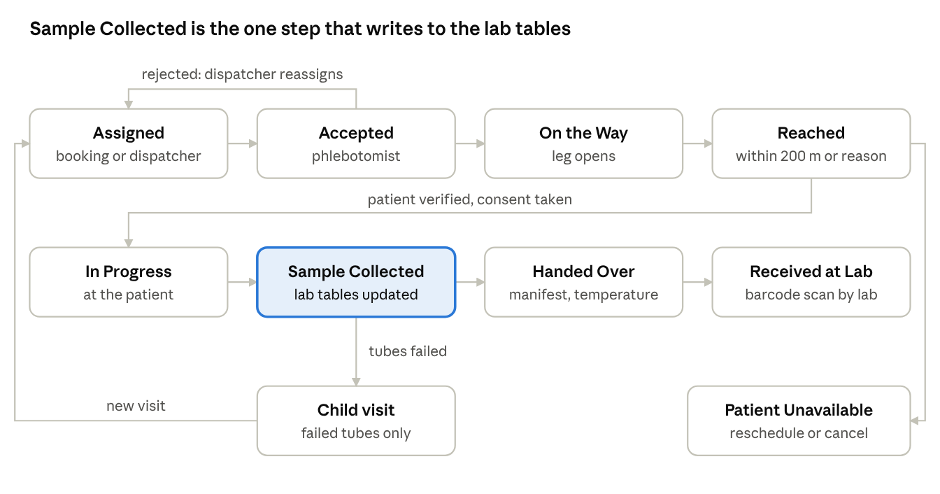
home collection visit · 8 statuses, 3 side paths
The top row is the journey to the door, and the middle row is the work there and the sample's trip to the lab. Rejection and failed tubes return to assignment, and an absent patient is rescheduled or cancelled.
Status | Set by | Requires | System effect
Assigned | Booking or dispatcher | Phlebotomist and slot | Visit created; push to phlebotomist; WhatsApp to patient
Accepted | Phlebotomist | Tap, or reject with reason | Rejection returns the visit to the dispatcher
On the Way | Phlebotomist | On duty; no other active visit | Leg opens; patient gets name, phone and arrival time
Reached | Phlebotomist | Within 200 m, or reason | Arrival time saved; leg closes
In Progress | Phlebotomist | Patient verified and consent taken | Shown as In Progress on web lists
Sample Collected | Phlebotomist | Every tube scanned or marked not collected; amount due settled or recorded | Writes SampleCollection status and time
Handed Over | Phlebotomist | Manifest of barcodes, at lab or to a runner | Custody moves; temperature saved
Received at Lab | Lab staff | Barcode scan; mismatches listed | Visit closes
Partial collection stays in the same visit. Tubes that fail use the existing Re Collect status and open a child visit. Other outcomes are Patient Unavailable, Rescheduled, Reassigned and Cancelled, and each needs a reason.
Offline. Each action is saved on the phone with a unique event id, device time and GPS, then replayed in order. The server ignores repeats, so a retry cannot double-collect. It also keeps its own receive time, and the 2203 rule already accepts a past collection time.
User id fix. SampleCollectionController read a UserId claim and fell back to user 1. Web and app tokens carry sub, not UserId, so collections were saved as user 1 even from the web screens. The controller now reads the real user id. LabReportingController, SampleTransferController, LabOrdersController and B2BBillingController still use the same claim and must be fixed before the app calls them.
Lab worklist. Reporting screens select samples with CollectionstatusID = 2, so a home sample appears as soon as it is collected, before it reaches the lab. Show it as In Transit, and block result entry until Received at Lab.

Bill change request
The phlebotomist requests a change and never edits the bill. The server prices the request, an approver decides, and the bill then changes under an audit record. EMR_Dev has no lab bill amendment today, so this is new work.
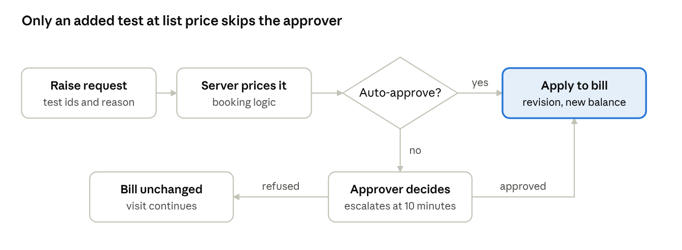
bill change request · 1 decision, 2 outcomes
Every request ends in one of two states: applied as a new bill revision, or refused with the bill unchanged.
Request | Approval (default) | Applied by
Add test | Automatic at the bill's rate list, no discount | New bill line, samples and barcodes
Remove test | Required; only before its sample is collected | Bill cancellation rules (2118)
Replace test | Required | Remove plus add, as one request
Discount or charge waiver | Always required | Existing discount fields, with approver recorded
Payment mode correction | Cashier; only before cash is deposited | Reversal and new payment entry
Name, age, gender, address | Supervisor | Patient update; age and gender also affect reference ranges
Rules that keep the bill safe:
- The phone sends only test ids and a reason. The server calculates price, GST, membership benefit and balance using the same logic as booking.
- Requests can be raised from Reached until Sample Collected. After that, the change is made at the branch.
- B2B and credit bills are blocked in the field, because the amount belongs to the partner's account.
- A refund is never paid from the phlebotomist's cash; the cashier processes it through the existing refund screen.
- The bill number stays the same. Each approved change adds a revision, and the revised bill goes to the patient on WhatsApp.
Approval. Reuse ApprovalMatrix and the Approval Dashboard (2277) by adding a module LAB.BILLCHANGE. Two differences matter. That workflow holds master changes, so bill changes need their own apply step. It also skips approval when no matrix is active, which is unsafe for discounts, so the API refuses those requests unless a matrix exists.
Waiting at the door. The approver gets a bell notification and the app shows a live status. After 10 minutes the request escalates. The visit can continue for unchanged tests, and tubes for an added test can be scanned only after approval.
Payment. Cash, UPI and card are recorded against the bill. UPI and card need a reference number. Cash joins a phlebotomist cash balance, which a cashier clears at day end against a deposit. EMR_Dev has no payment gateway link, so online confirmation is a later phase.
PaymentService and CancellationService live in EMR.Web, not EMR.Api. Move the shared logic so both apps use one code path; do not write a second version.

Other field functions
These functions complete a working field day, and most reuse existing masters. Each is listed with the phase it belongs to, and the plan at the end explains the phases.
Function | How it works | Reuses | Phase
My Day list | Today's visits by slot, with urgent first, tests, tubes, fasting note and amount due | LabOrder, IsUrgent | 1
Navigate and call | Opens the phone's map app; call button uses a masked number if available | Visit coordinates | 1
Patient verification | Two identifiers plus OTP on WhatsApp; if OTP fails, photo of ID with a reason | WhatsAppService | 1
Consent and prescription | Consent on screen with signature; photo of prescription | Consent masters, LabFtpService | 1
Barcode | Camera scan of pre-printed labels, linked tube by tube, with a duplicate check | Barcode rules (2312), Franchise barcode | 1
Failed draw or refusal | Reason chosen from a list, for each tube | Sample rejection reason master | 1
Reschedule or cancel | Phlebotomist requests; dispatcher confirms; cancellation follows bill rules | usp_Bill_Cancel | 1
Handover manifest | Barcode list with temperature; lab scans to accept | Sample Transfer pattern | 2
Cold chain | Box temperature at start and handover; time since collection warns at a limit | New setting | 2
Kit stock | Tubes and needles issued and used per day | Inventory, if the client uses it | 3
Patient tracking link | Expiring link, live only while On the Way | Location points | 3
Feedback | Five-point rating with comment at the door, or a WhatsApp link | WhatsApp | 3
SOS | Emergency call button that also sends location and an alert to the supervisor | Location points, bell | 3
Sync and signal status | GPS and internet indicators, with Sync Update and Sync Test tiles | Offline event queue | 1
Vial count | Tubes collected for the day, checked at handover | Barcode records | 2
Leave request | Phlebotomist applies; supervisor approves; dispatch excludes that person | Attendance | 3
Phlebotomist rating | Patient ratings averaged and shown on the dashboard | Feedback | 3
Create booking | Optional, for walk-up requests at a visited address | Lab booking | 3
Phone push needs a new service, such as Firebase Cloud Messaging, because today's bell runs on SignalR for open web tabs. WhatsApp stays the patient channel.

Data model and API
All logic goes in new usp_Phlebo_* stored procedures behind a new api/phlebo controller, matching the Lab rule. SQL scripts start at 2357, and the data dictionary is refreshed after they run.
New table | One row per | Key columns
LabHomeVisit | Visit | LabOrderId, PhlebotomistId, slot, status, address snapshot, latitude, longitude, ParentVisitId
LabHomeVisitEvent | Status change | VisitId, status, ClientEventId (unique), device time, server time, GPS, distance from address, reason
PhleboDevice | Phone | UserId, device id, status, approved by, last seen
PhleboAttendance | Duty day | UserId, date, punch in and out with GPS, shift, day status, review status
PhleboLocationPoint | GPS point | UserId, AttendanceId, time, latitude, longitude, accuracy, speed, mock flag
PhleboTravelLeg | Leg | AttendanceId, from and to events, GPS km, road km, payable km, review status
LabBillChangeRequest | Request | LabOrderId, VisitId, type, reason, old and new totals, status, ApprovalRequestId
LabBillChangeLine | Changed item | Request, action, investigation, price, tax
LabBillRevision | Applied change | LabOrderId, revision number, snapshot, applied by
PhleboCashLedger | Cash movement | UserId, LabOrderId, amount, type, deposit reference
PhleboHandover | Manifest | Phlebotomist, receiver, time, temperature, plus a line per barcode
PhleboStartPoint | Hub or centre | Company, name, latitude, longitude, radius
PhleboLocationPoint will be the largest table, so partition or purge it by date. Add latitude, longitude and radius columns to the branch record as well.
Method | Route | Purpose
GET | api/phlebo/session | Profile, duty state, settings, device status
POST | api/phlebo/device/register | Register a phone for approval
POST | api/phlebo/attendance/punch | Punch in or out
POST | api/phlebo/location/batch | Upload GPS points
GET | api/phlebo/visits | My Day list
GET | api/phlebo/visits/{id} | Tests, tubes, patient, amount due
POST | api/phlebo/visits/{id}/events | Status change, safe to repeat
POST | api/phlebo/visits/{id}/verify | Send and check OTP
POST | api/phlebo/visits/{id}/samples | Collect by barcode, or mark not collected
POST | api/phlebo/visits/{id}/payment | Record a payment
POST | api/phlebo/visits/{id}/documents | Prescription, consent, ID photo
POST, GET | api/phlebo/bill-changes | Raise and follow requests
POST | api/phlebo/handover | Submit a manifest
GET | api/phlebo/summary | Day's distance, cash and target
Every route is mapped to LAB.PHLEBOAPP in Settings > Security, because unmapped endpoints are refused for access tokens.

Web screens, reports and settings
The office needs a dispatch board and approval queues, and each rule needs a per-company setting. Seeded values are starter defaults, and clients change them.
Screen | Used by | Purpose
Home Collection Dispatch | Dispatcher | Map and list of visits, assign, reassign, reschedule, late alerts
Phlebotomist Live | Supervisor | On-duty staff, current visit, last location time
Attendance Review | Supervisor | Late, outside radius, mock location, corrections
Travel Claim Approval | Supervisor | GPS km, road km and payable km by leg, with map replay
Bill Change Requests | Approver | Approval Dashboard, with old and new bill side by side
Phlebotomist Cash | Cashier | Balance by person, deposit, day-end clearance
Device Approval | Supervisor | Approve, replace or revoke phones
Sample Handover | Lab reception | Scan manifest, list mismatches
The existing Sample Collection list gains a visit status column, and the booking screen gains a slot and optional assignment. Reports to add are visit turnaround, on-time arrival, failed visits by reason, collections against DailyCollectionTarget, distance and incentive, and cash outstanding.
Setting | Starter value
Branch or start point radius | 200 m
Patient arrival radius | 200 m
Outside radius action | Flag for review (other option: block)
Late grace | 15 minutes
Duty photos and temperature reading, each | On
Field start allowed | Off
Location interval | 60 seconds or 100 m
Payable km tolerance | 1.15
Rate per km, visit incentive | Set by client, by vehicle type
OTP required | On
Accept timeout, when the step is on | 30 minutes
Bill change escalation | 10 minutes
Add test auto-approve | On
Cash holding limit | Set by client
Location retention | 90 days
Accept step | Off
OTP point | At arrival (other option: at completion)

Delivery plan, risks and decisions
Deliver in three phases, each usable alone. No dates are set until the app technology and team are decided.
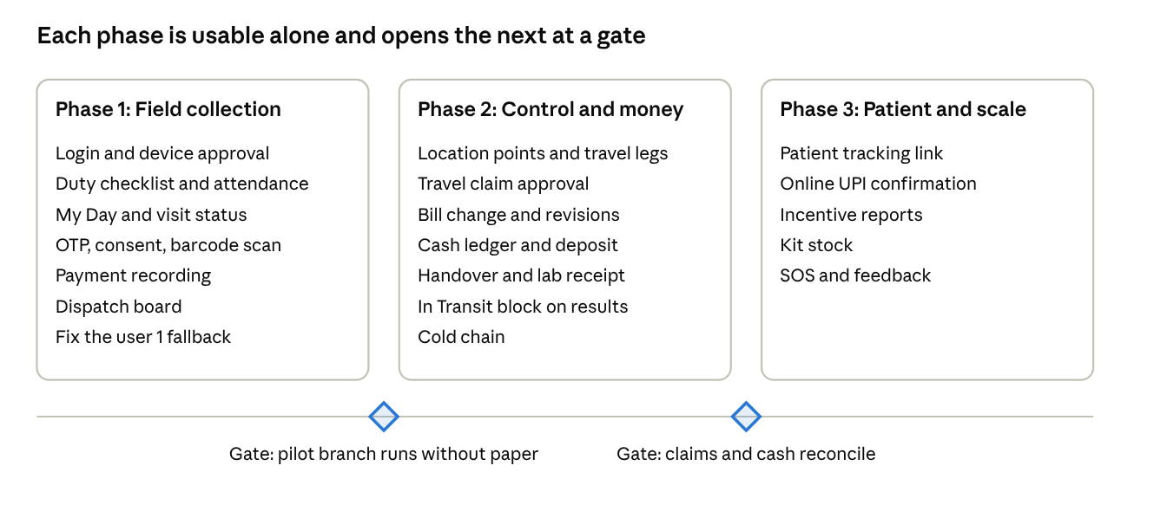
delivery phases · 3 phases, 2 gates, not to time scale
Phase 1 replaces the paper visit. Phase 2 adds the items that touch money, because they need real field data to test against.
Risks
Risk | Response
Android kills location to save battery | Foreground service, a battery exemption prompt, gap flags and map replay
False GPS | Mock location check, server legs, supervisor review
Staff resist tracking | Record on duty only, show it clearly, tie to travel pay
Field discounts leak revenue | Server pricing, approval, audit, revision history
Cash shortage | Daily balance, holding limit, cashier clearance
Patient data on a lost phone | App lock, device revocation, local wipe, minimal local storage
Play Store rejection | Prepare the disclosure and video early
Decisions needed
- ☐ Confirm bill change, distance and cash handling in a live itDose demo or login
- ☐ App technology: Flutter recommended for one Android and iOS code base; choose native Kotlin if Android-only tracking proves unreliable
- ☐ Distribution: one app showing the client's logo after login (recommended), or a branded app per client
- ☐ Road distance provider: Google Routes, or GPS km only
- ☐ Travel pay: per km rate, visit incentive, or both, by vehicle
- ☐ Payment gateway for UPI confirmation in phase 3, and which provider
- ☐ Whether result entry stays blocked until Received at Lab for all clients

Sources
Code evidence comes from EMR_Dev at commit e1df01b and its working tree. Limits and intervals are proposed defaults, not figures from a source.
- CrelioHealth home collection
- MocDoc phlebo app
- Drlogy phlebo management
- Techjockey itDose listing
- Google Play location policy
itDose apps on Google Play, descriptions and screenshots read on 2026-11-01:
- Phlebo App
- Pacific Phlebo
- Apollo Home Collection
- AD Phlebo App
- Lupin Home Collection
- Lupin Log Track
- Apollo Logistics App

